MYSQL

ATTENDANCE MANAGEMENT SYSTEM



INTRODUCTION

" Attendance Management System” is software developed for maintaining the attendance of the student on the daily basis in the collage. Here thestaffs, who are handling the subjects, will be responsible to mark the attendance of thestudents. Each staff will be given with a separate username and password based onthe subject they handle. An accurate report based on the student attendance isgenerated here. This system will also help in evaluating attendance eligibility criteria of a students report of attendance on weekly and monthly basis is generated. "

.

Aim : project Attendencess managenment system save time .display record time to that time. manual presenty save time .

ABSTRACT

"Student attendance management system deals with the maintenance of the student’s attendance details. It is generates the attendance of the student on basis of presence in class. It is maintained on the daily basis of their attendance. the staffs will be provided with the separate username & password to make the student’s status".

"The staffs handling the particular subjects responsible to make the attendance for all students. Only if the student present on that particular period, the attendance will be calculated. The students attendance reports based on weekly and consolidate will be generated."

OBJECTIVE:

“Attendance Management System” is software developed for maintaining the attendance of the student on the daily basis in the collage. Here thestaffs, who are handling the subjects, will be responsible to mark the attendance of thestudents. Each staff will be given with a separate username and password based onthe subject they handle. An accurate report based on the student attendance generated here. This system will also help in evaluating attendance eligibility criteria of students.

PROJECT OVERVIEW

1.STUDENTS

STUNAME

STUID

COURSE

DEPARTMENT

2.ATTENDENSS

TEACHERID

STUDENTID

STUDENTSNAME

SUBJECT

TIME

ATDATEOF

STATUS

3 TEACHERS

TEACHERID

TEACHERNAME

ER DIAGRAM

Attendeness Management System

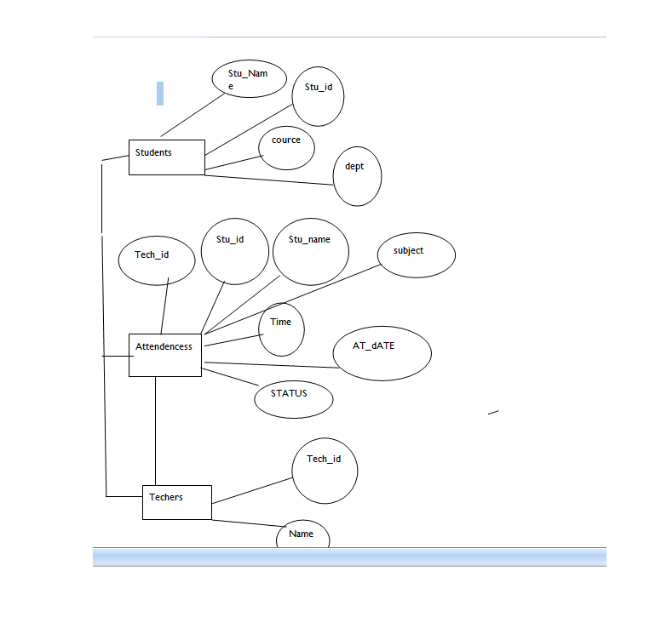

1. CREATE DATABASE STUDENTS

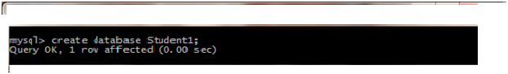

2. CREATE TABLE STUDENTS

create students table follwing the way thus .

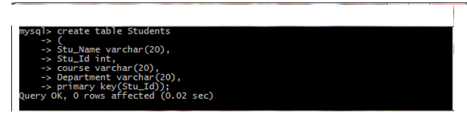

DESC TABLE STUDENTS

Follwing the describe of the desc students the table observe table desc of the table which way desc students

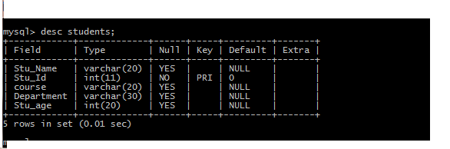

3.INSERT VALUES IN STUDENTS

insert into values in students the table of the which way follwing .

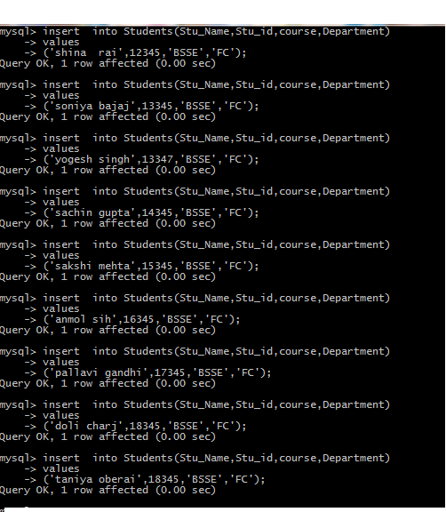

SHOW THAT THE TABLE STUDENTS

select * from students then the show table.

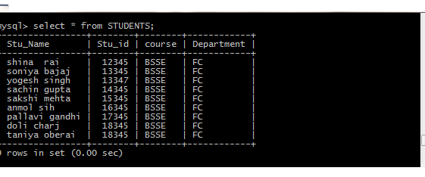

4. CREATE TABLE ATTENDENCESS

create table attendencess of the create the follwing way explain then the create table.

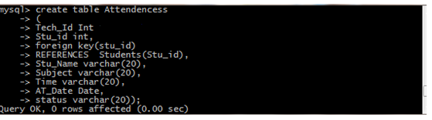

DESC TABLE ATTENDENCESS

you have describe the table Attendencess show of the follwing way

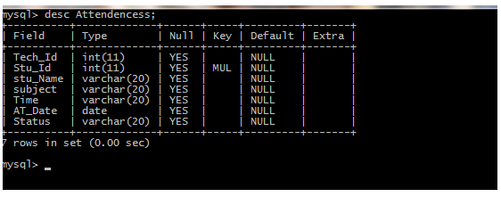

INSERT INTO VALUES ATTENDENCESS

Insert into value attendencess of the table way of follwing

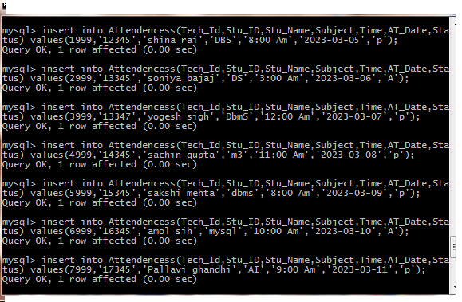

6.DISPLAY ATTENDENCESS

display the table then you can then you can this table observe then null values create then you have the update table thus you have display the select slash from display tablename then show table.

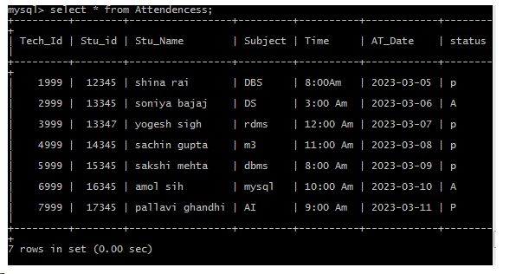

DESC ATTENDENCESS

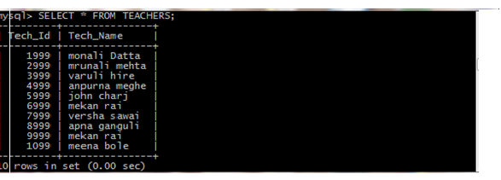

7. CREATE TABLE OF TEACHERS

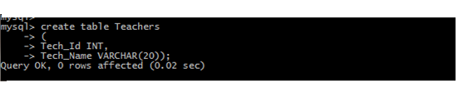

DESC TEACHERS TABLE

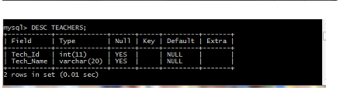

INSERT INTO VALUE OF THE TEACHERS TABLES

insert the value of the table name is teachers then the you first insert the column name then table you have create the query. then put the values of the teachers table.

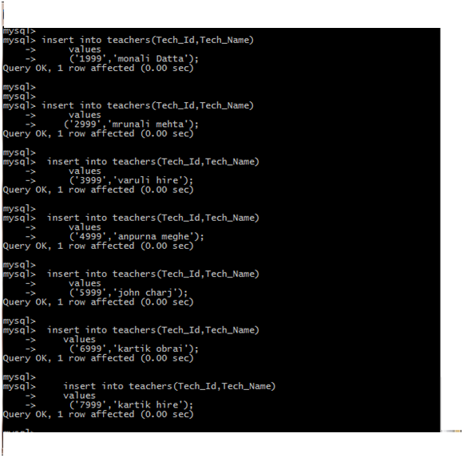

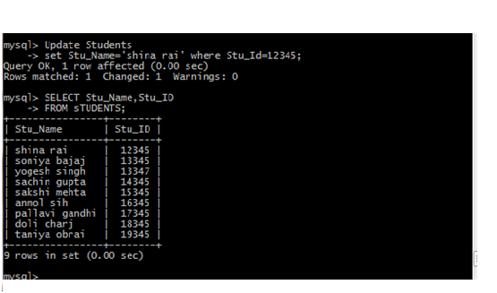

8. UPDATE STUDENTS TABLE

Updating stu_name where stu_id=12345 of th students table.

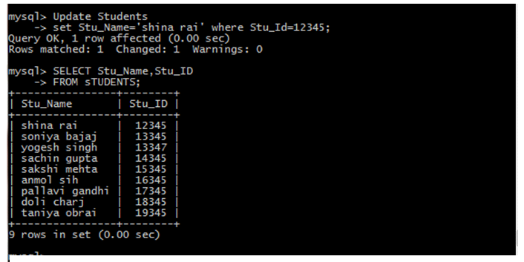

Updating the studnts of the Stu_Age where Stu_Id=13345;

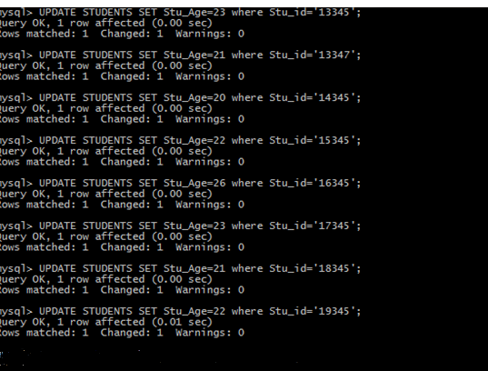

9.CHANGE TABLE

change of th tables of students drop the stu_age column.

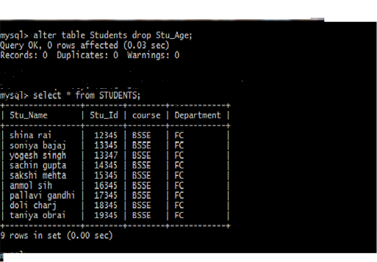

10.MODIFY TABLE

modify datatype of department number datatype varchar.

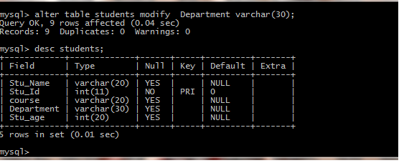

11.NOT OPEROTOR

student not age =22 then not operator use.

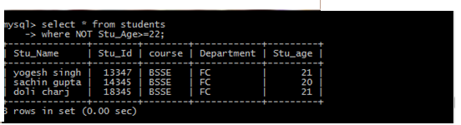

12. LIKE OPERATOR

Name that include s

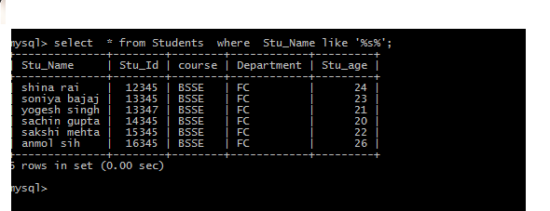

LIKE OPERATOR

Name that contains t,q,f letters

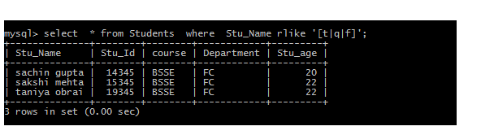

Names that ends from a.

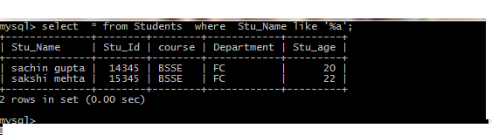

Names that include a

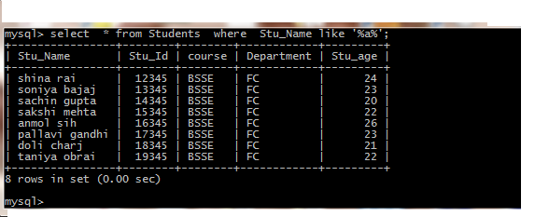

Names that starts from s.

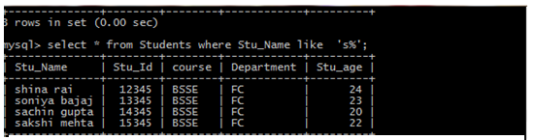

13. ORDER BY QUERIES

students records stu_id all the records ascending orders follwing .

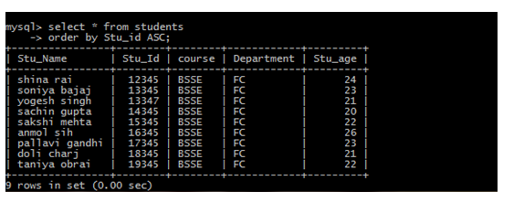

students records Stu_Name the records descending orders follwing .

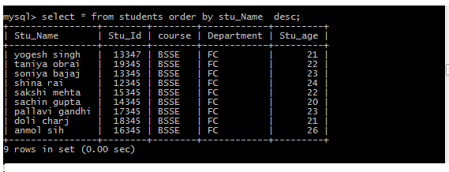

14. GROUP BY

group students of the stu_age aggrigate function use.

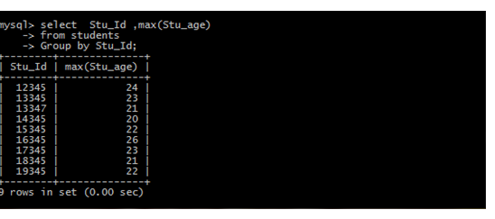

15.OR OPERATOR

or operator of fetch two record using .

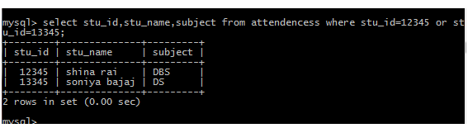

16.AND operator

fetching single record by giving multiple data and operator

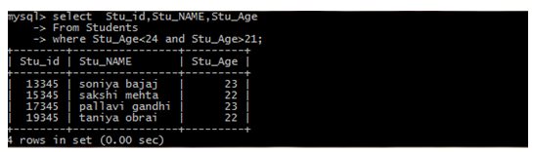

17.DISTINCT

select unique stu_age from table

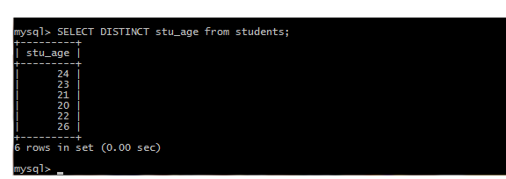

18.LESS THAN EQUAL TO THE STUDENTS.

find Stu_id less than equal to 21

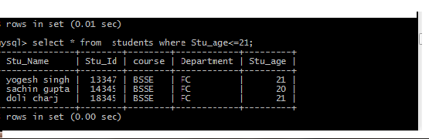

19.GREATER THAN EQUAL TO STUDENTS

find stu_age greater than equal to 21

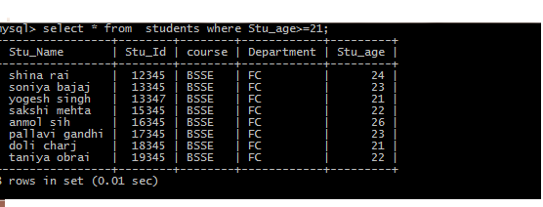

20.IN OPERATOR

find details of Stu_id 12345.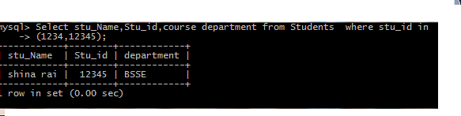

length of charactor Stu_name from students table

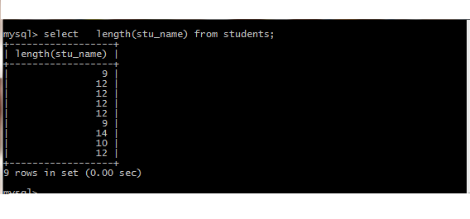

UPPER STUDENTS NAME

uppercase of this stu_name from students

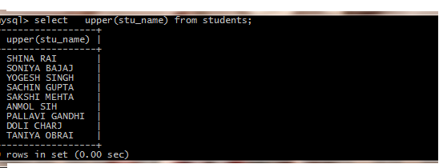

lowercase of the Stu_name from students

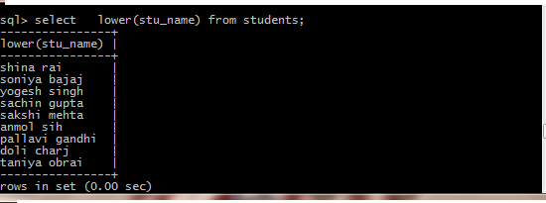

21.BETWEEN OPRATOR

finding details of Students who has stu_age range 21 and 22

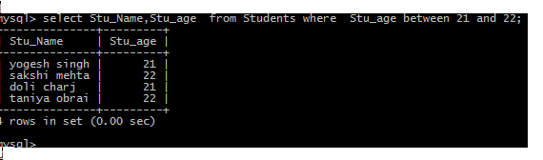

21.WHERE CLAUSE

show details of this who has specific Stu_id.

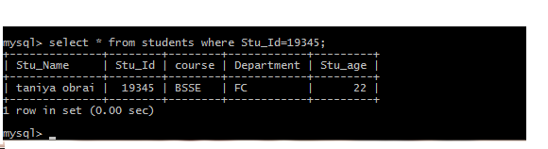

22.Alias

give temporary name to Stu_Name students table.

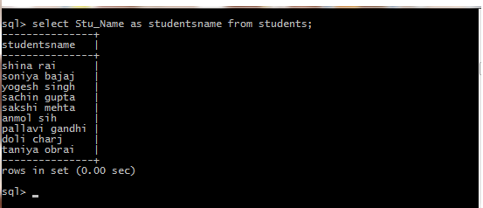

23.INNER JOIN

inner join of the students table and attendencess.

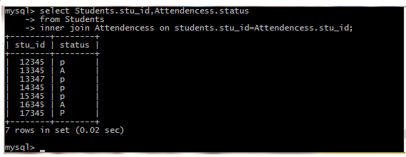

LEFT JOIN

left join of the students table and attendencess table.

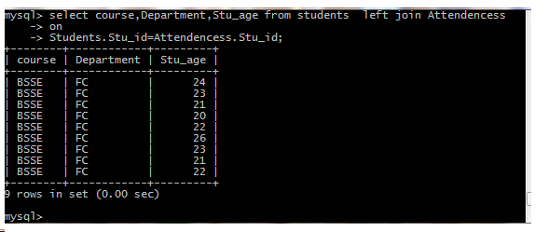

RIGHT JOIN

right join of th students table and attendencess table.

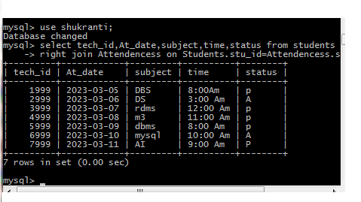

CROSS JOIN

students of the cross join into of th students and attendencess of this table.

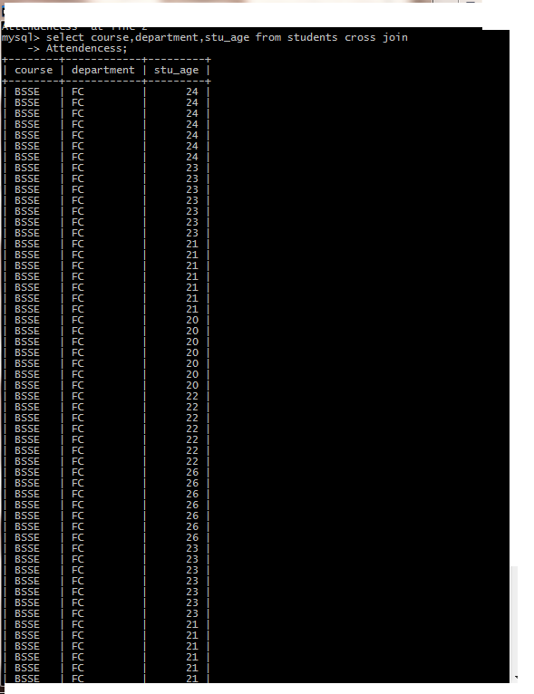

IN OPERATOR

find details of the Stu_id 12345.



24. LIMIT

Details of Stu_id who has stu_id 3r last.

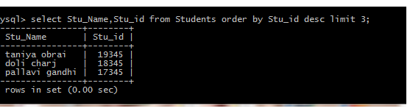

details of stu_id who has stu_id 2nd last.

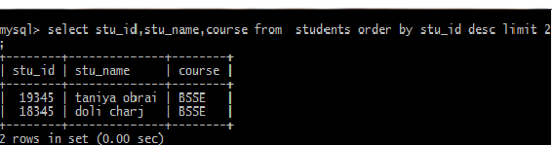

25.VIEW

Give tempory name table students tables name then create view.

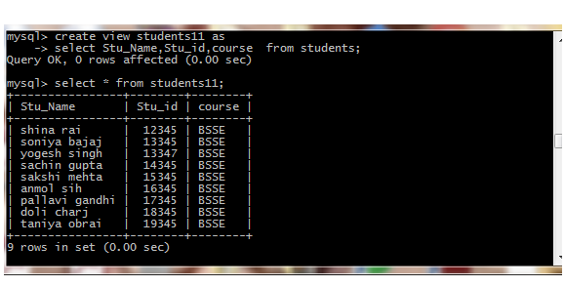

26. AGGRIGATE FUNCTION

students count from students tables ,students avg of table students age, students stu_age min aggrigate fuction use max of age students aggriate fuction max

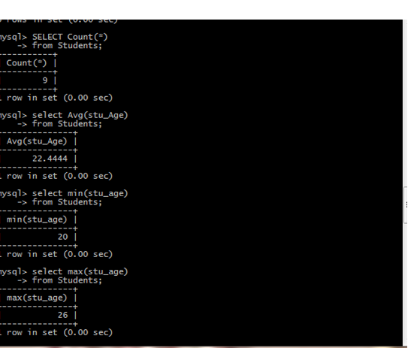

BUILT IN FUNCTIONS

DATETIME

Display curdate today date .

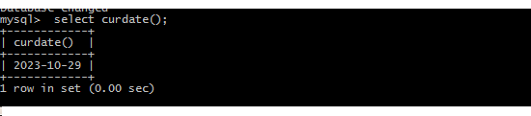

Display now today date and time.

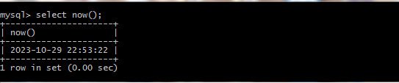

Display lastday month.

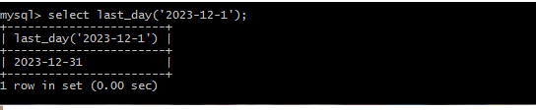

Display lastday day month curdate.

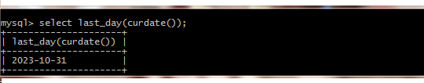

Display year now.

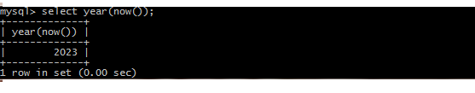

Display now month sysdate.

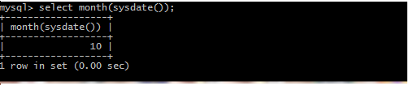

STRING

Display concat.

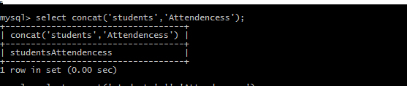

Display concate students and attendencess

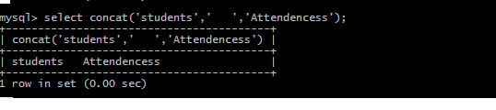

Display lower attendance management system.

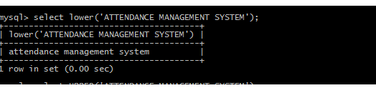

Display upper attendance management system.

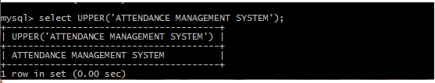

25. SUBQUERY

SUBQUERY

find Attendencess students record count then display stu_id,status,tech_id.

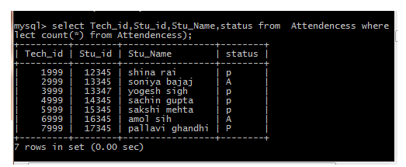

find Attendencess table teachear giving attendence then present and absents students status ,stu_name,stu_id display.

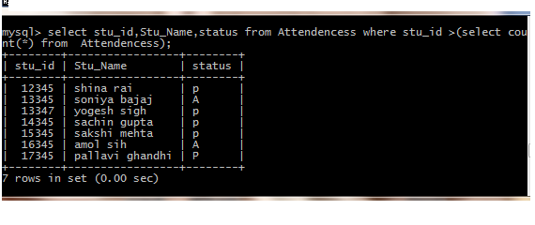

find Attendencess of the table this of giving teacher attendencess that time result show

of the teacher giving stu_id,tech_id,status Attendeness.

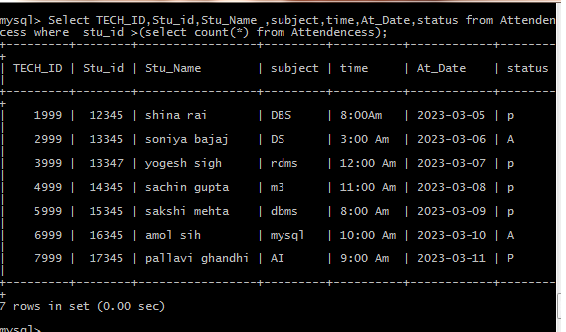

Display record of table of this Attendencess record present of this lecture only present status students .

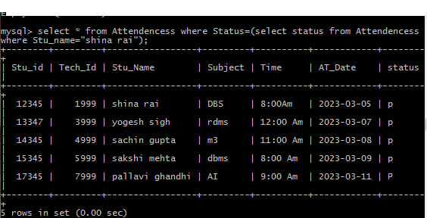

Attendencess of the table teacher giving attendencess then absent of the record display.

thus not attend lecture then they record display.

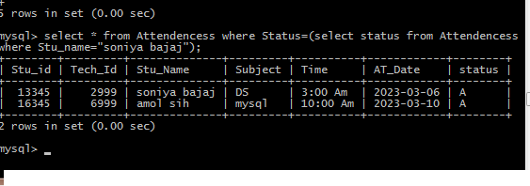

ATTENDENCESS ONLY OF THIS ONLY RECORDS DISPLAY STU_ID WHAT THEY DISPLAY

only of this record display we have giving stu_id then not display other record .

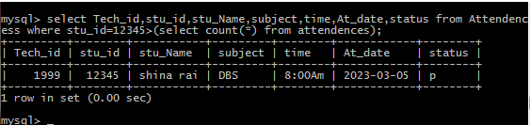

Display attendencess table for the absent record only teachers of absent .

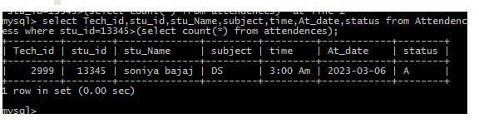

THANK YOU